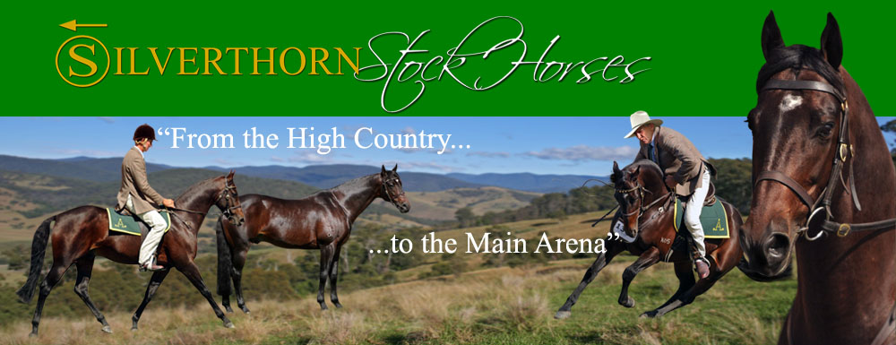
Paul Wardell Clinic
13th & 14th May 2017
New England Girls School
Indoor Arena
New England Highway - Armidale
Starting 8.30am
A 2 day Clinic with Paul Wardell from Silverthorn Stock Horses will be held at NEGS Indoor Arena. Paul is a level 1 coach with a current First Aid Certificate. Paul and his team are still currently competing with numerous successful results.

The Clinic is open and suitable to Riders/Horses of ALL ages and levels.
The cost for the weekend is 250.00/rider. This includes full use of the indoor all weather arena and morning and afternoon tea. Toilet and shower facilities are available. Numbers are limited for the Clinic, so it is advised to book a spot ASAP. Places will only be secured when payment is received. Refunds will only be given if a replacement rider is found. All riders must wear an approved helmet and do not have to be members of the ASH Society, however, a waiver must be signed before mounting their horse.

Stables are $20.00 per night, and camping $25.00 (if you have a generator it would be advisable to bring it, as there is limited power).

Payment:
Regional Australia Bank - BSB: 932 000 A/C: 959185 (Stacey Drew)
Ref: Wardell Clinic & Surname

Please fill out details, attach payment and return to address below to secure your position. A waiting list will be organized if need be.

Paul Wardell ASH Clinic
13th & 14th May 2017
New England Girls School
Indoor Arena
New England Highway – Armidale
$250/Rider

NAME:______________________________________________________________________

ADDRESS:____________________________________________________________________

EMAIL:_____________________________________________________________________

PHONE:_____________________________________________________________________

AGE if under 18_______________________________________________________________

- I am attending with a Stallion/Colt

- Stables @ $20.00/night includes bedding (arrange with Negs)

- Powered camping site @ $25.00 for the duration (arrange with Negs)

**Please DO NOT add stable or camping fee to the clinic fee. Please contact negs to arrange your stables and camping on 6774 8717.

Post to:
Stacey Drew
44 Rowan Ave
Uralla NSW 2358
Mob: 0427 418 228
staceyjdrew@gmail.com

**Please attach your payment receipt or email notification of direct deposit. A confirmation email will be sent out when form/payment received.

